Process Description-

We have a copy of standard porting LOA for porting geographic numbers (GNP) as following for a walkthrough with details-

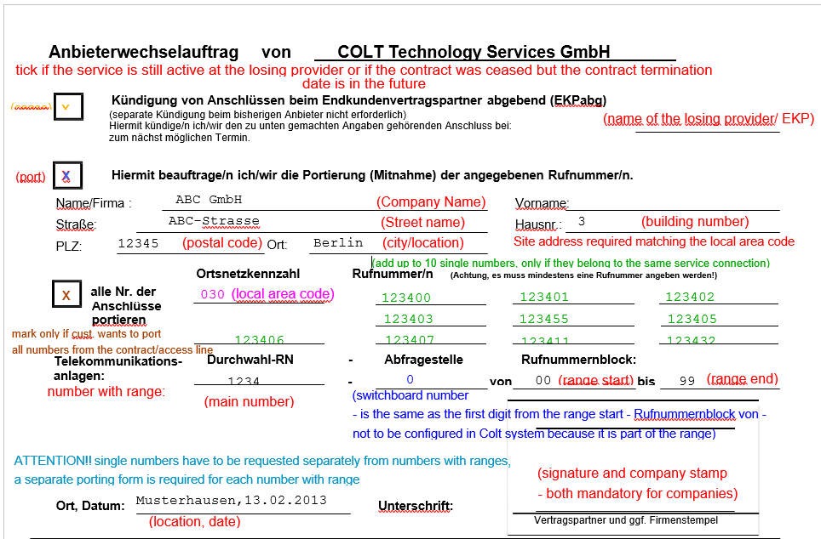

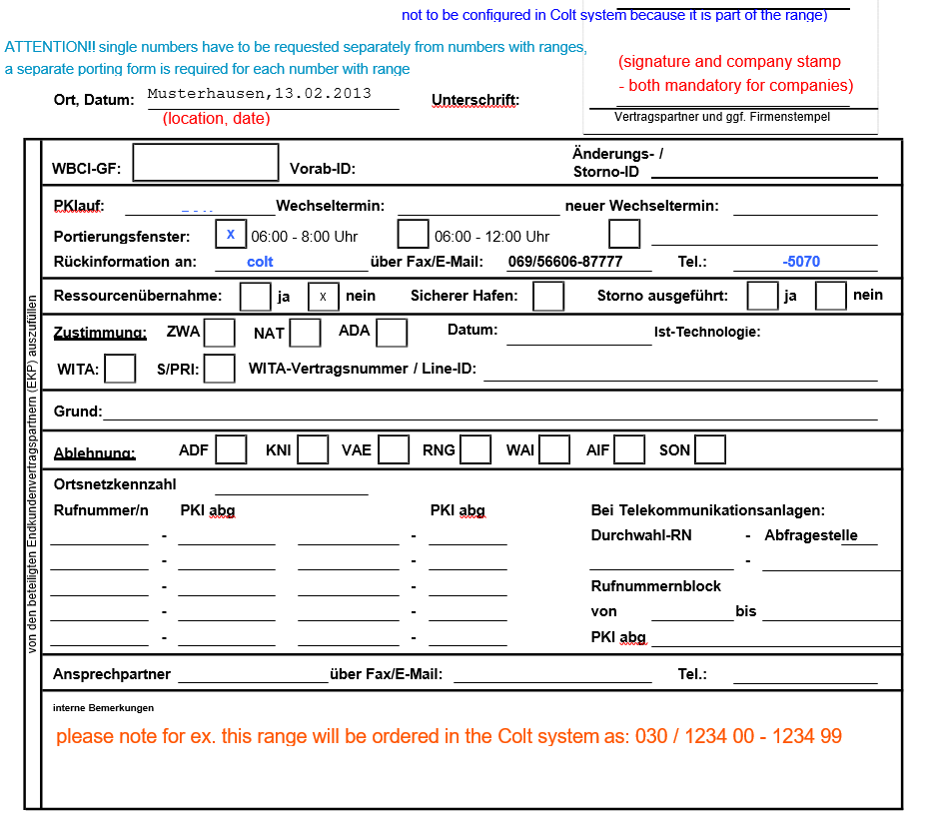

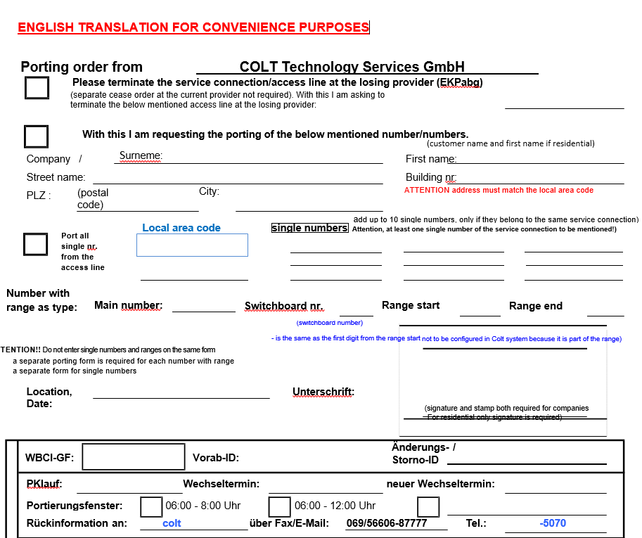

- Please terminate the service connection/access line at the losing provider (EKPabg) – If you do not mark this box porting without contract termination "Kündigung von Anschlüssen ..." is only possible for number with ranges if the contract was terminated and the cease date is in the past. As long the contract is still active at the losing provider or terminated with a future cease date, porting incl. contract termination should be requested (tick the box: Kündigung von Anschlüssen…)
- With this I am requesting the porting of the below mentioned number/numbers- This always has to be marked

According to the German regulatory rules:
A range is defined as a multiple of 10 or 100 or 1000 or 10000 numbers, the multiplier by definition smaller or equal to 10.
This means 10, 20, 300, 500, 3000 is fine, 1200 is wrong.
The last digit of the range start must be ‘0’, the last digit of the range end must be ‘9’.
We are not allowed to port a part of a number range or to split a range in more ranges; according the regulatory rules in Germany we are only allowed to port full number range as they were originally assigned
A number is formed of maximum 11 digits including the digits of the range and without counting the leading Zero of the local area code.
There are some exceptions for single numbers that can’t be ported because they are too long, technically not portable.

Exception for single numbers in Berlin, Frankfurt, Munchen, Hamburg:
If we have a local area code of 3 digits (030) the complete number, without counting the leading 0 should be formed of:

· max. 10 digits for single numbers (with a local area code of 3 digits 030, 069, 089, 040…) ex 030 12345678 (030 123456789 would be too long, 11 digits)

· max. 11 digits for numbers with number ranges (030 123456780 – 123456789 would be ok 11 - digits)

Note: Please keep a copy of latest invoice handy while filling out the LOA with following inputs required.
FOR INTERNAL SYSTEM RECORDS The switchboard number (Switchboard nr. / Abfragestelle) is the same with the first digit of the range start (Runummernblock von) and should not be configured within the Colt system, because it is already part of the range

